Exmoor Link Healthy Eating Policy
- The benefits of healthy eating are substantial. Nutrition related diseases are increasing in the UK. One of the major threats to health is obesity. Schools have a key role in encouraging a healthy diet to help achieve the Public Service Agreement to halt the year on year rise in obesity.
- Childhood obesity and excess weight are significant health issues for children and their families. There can be serious implications for a child’s physical and mental health, which can continue into adulthood. The number of children with an unhealthy and potentially dangerous weight is a national public health concern.
- Under OFSTED’s Common Inspection Framework, OFSTED now inspect how “children and learners keep themselves healthy, including through healthy eating.” Inspectors will look at “food on offer and visit the canteen to see the atmosphere and culture in the dining space and the effect this has on pupils’ behaviour.”
- There are clear benefits to the children and the school in terms of the influence on school attainment and behaviour.
- The future health of individuals can be influenced by their diet in childhood.
- Healthy eating contributes to a feeling of well-being.
Statistics
- 10.7% of 3 year olds in England (whose parents gave consent for this survey) had experienced tooth decay (2013) and this becomes around 25% at 5 years old (2017)
- Children with tooth decay experience had on average 3 teeth that were decayed, missing or filled (at age 3 most children have all 20 primary teeth) (2013)
- Regularly consuming food and drinks high in sugar increases the risk of tooth decay, and can lead to an increased risk of obesity and type 2 diabetes. Children are still consuming more than the recommended daily limit.

Our school is dedicated to providing an environment that promotes healthy eating and enabling pupils to make informed choices about the food they eat. This will be achieved through PSHE lessons, cooking in class and a whole school approach to food and nutrition.

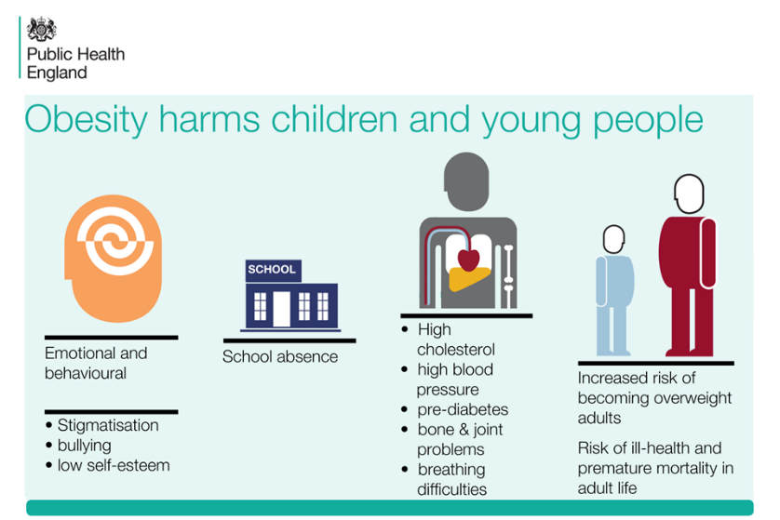
Food and Drink provision throughout the day
Breakfast
Breakfast is an important meal that should provide 25% of a child’s energy requirement and contribute significantly to their vitamin requirements.
Our school offers a breakfast club that provides a nutritious meal for pupils before the start of the school day. Additional information is available from the school office.

Lunch
School lunches are prepared by our catering team on site, and meet the National Nutritional Standards for School Lunches. All menus are produced in accordance with current Food Standards for school lunches. The catering manager regularly informs parents about termly menus and promotes the healthy school meals available through the newsletter and the website. This encourages the uptake of school dinners. The school office also makes the forms for the uptake of Free School Meals freely available to parents.
School lunch portion sizes are in line with National Standards for school lunches which can be found here: (https://www.publichealth.hscni.net/sites/default/files/Nutritional%20standards%20for%20school%20lunches%20-%20a%20guide%20for%20implementation%2009_10.pdf)
All Foundation Stage and Key Stage 1 children are offered a Free School Meal and this is explained to parents when their children start school.

Packed lunch
The school dinner staff are aware of what is in packed lunches and promote healthy options. The school will raise awareness and aim to inform parents, carers and pupils about the healthy choices available for packed lunches.

Special Dietary Requirements
Vegetarians
The school catering team offer a vegetarian option at lunch everyday.
Food intolerances and allergies
Individual care plans are created for pupils with food allergies. These document symptoms and adverse reactions, actions to be taken in an emergency and emergency contact details. School caterers are made aware of any food allergies/intolerances and requests for special diets are submitted according to an agreed process.

Snacking
The school understands that snacks can be an important part of the diet of young people and can contribute positively towards a balanced diet. We also acknowledge that children are more likely to be able to concentrate and therefore progress when they are not hungry.
Foundation Stage
Foundation Stage children are part of the National Fruit and Vegetable scheme, receiving free fruit/vegetables on a daily basis. Children under 5 are also able to request daily milk for their snack as part of the Cool Milk Scheme.
In the Foundation Stage, all staff who prepare snack have a valid Food Hygiene Certificate. Staff are aware of food allergies and intolerances and make sure to consider this when preparing snacks.
Key Stage 1 and 2
Children in Key Stage 1 are also part of the National Fruit and Vegetable scheme, receiving free fruit/vegetables on a daily basis.
Children in Key Stage 2 are encouraged to bring their own healthy snack to school to eat at breaktime. We recommend they bring fruit or vegetables but acknowledge that a range of other foods can also be considered a healthy option – cheese, crackers, rice cakes or a nutritious sandwich separate from their packed lunch. Where possible, we discourage prepacked snacks due to their often high sugar content and also the environmental impact of the plastic wrappers.
Tuck shop
Key Stage 1 and 2 children have access to a tuck shop most days each week. The tuck shop serves a range of healthy snacks – soup, cheese, toast, rice cakes etc. Prices can be gained from the school office or class teachers.

Drinking water
The National Nutritional Standards for Healthy School Lunches recommend that drinking water should be available to all pupils, everyday, and free of charge.
Fresh drinking water is encouraged for both children and staff throughout the school day. The children keep their water bottles in their classrooms and are encouraged to drink and refill throughout the day. In Foundation Stage, the water bottles are kept in a central box at child height and children have free access to this throughout the day. They are encouraged to have a drink at their 2 snack times and at lunchtime.
The Foundation Stage children participate in the Cool Milk Scheme.
Special events
For birthdays, cakes or cookies are allowed to be brought in by the children to share. We generally discourage sweets due to the high sugar content and plastic wrappers but understand that it will sometimes be necessary for children to choose this instead.
References
https://www.publichealth.hscni.net/sites/default/files/Nutritional%20standards%20for%20school%20lunches%20-%20a%20guide%20for%20implementation%2009_10.pdf
https://www.gov.uk/government/statistics/oral-health-survey-of-3-year-old-children-2020#:~:text=10.7%25%20of%203%20year%20olds,have%20all%2020%20primary%20teeth
https://www.gov.uk/government/publications/child-oral-health-applying-all-our-health/child-oral-health-applying-all-our-health
https://www.gov.uk/government/publications/childhood-obesity-applying-all-our-health/childhood-obesity-applying-all-our-health

Written by S. Bale
Review date: Sept 2024

